Connecting Python to Neo4J

1. Click on ‘Add Graph’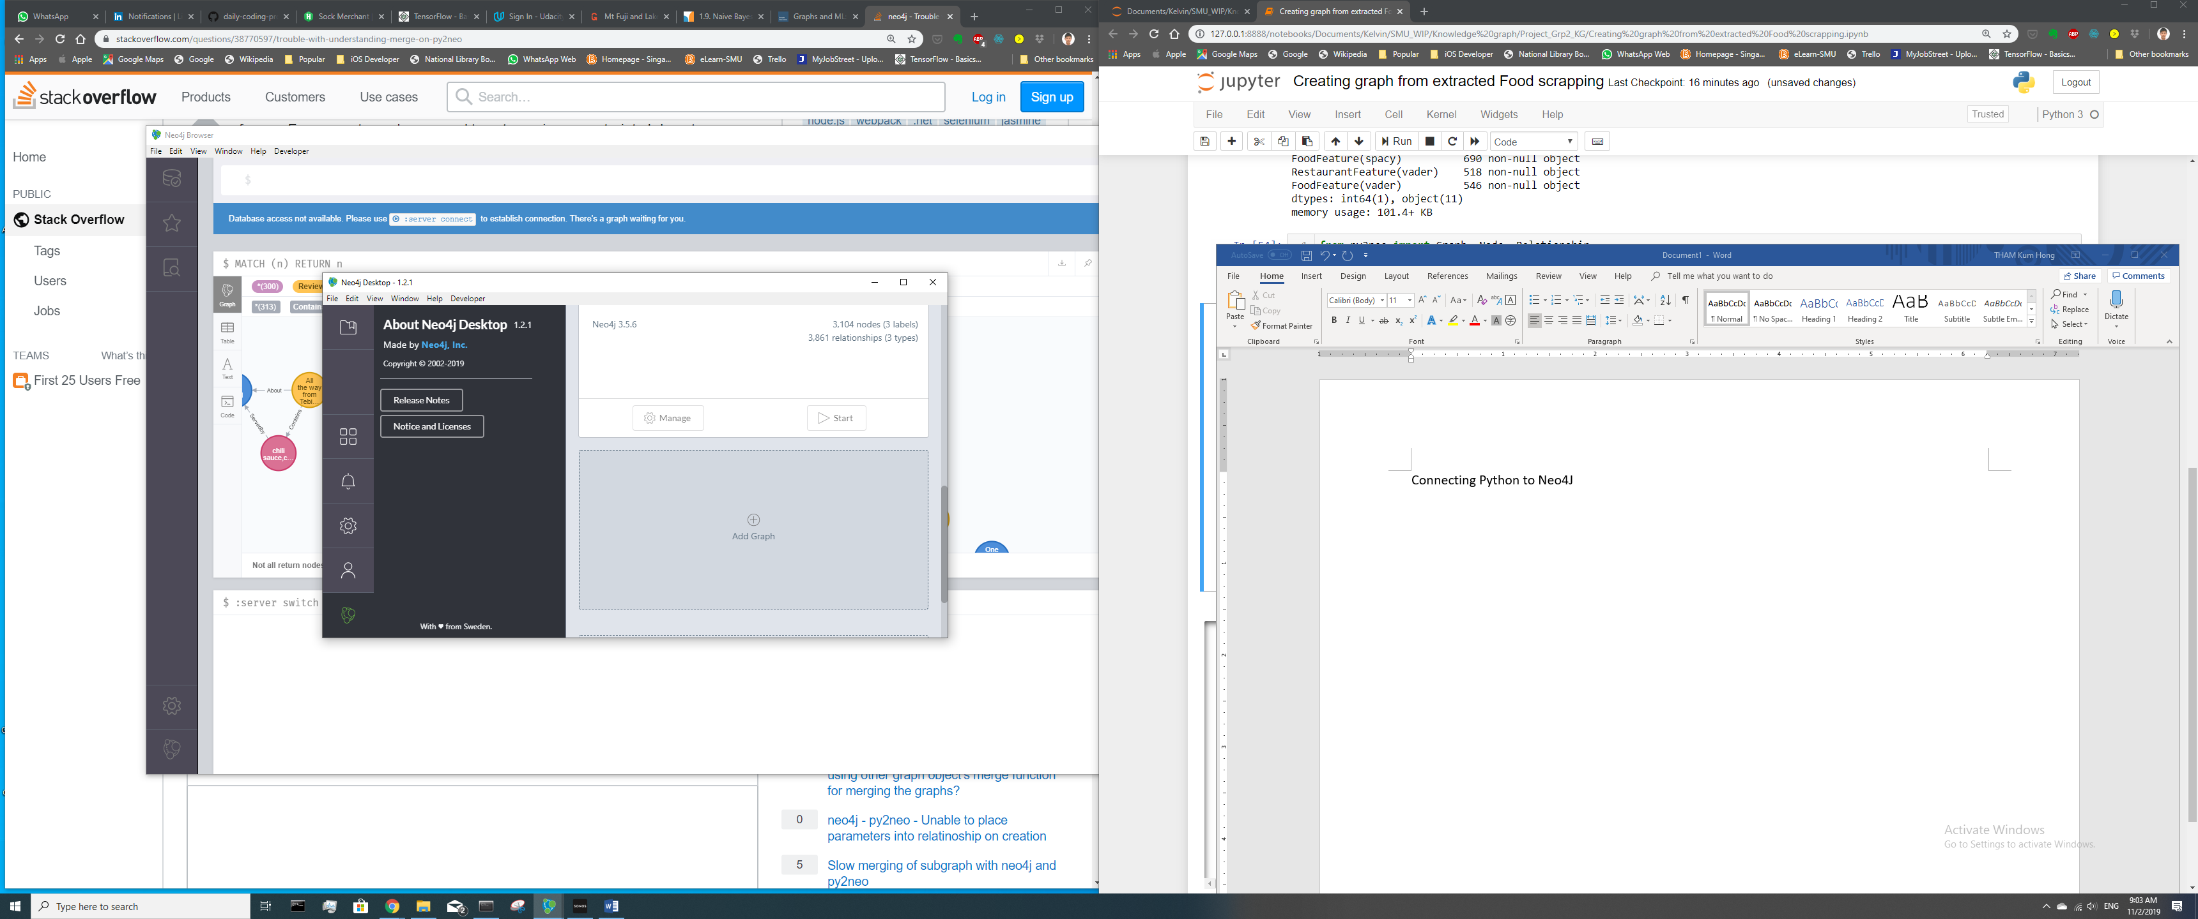
2. Click on ‘Create a Local Graph’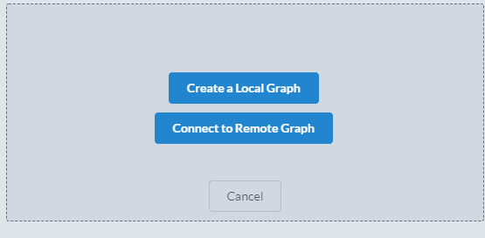
3. Set password. Graph Name can be anything. 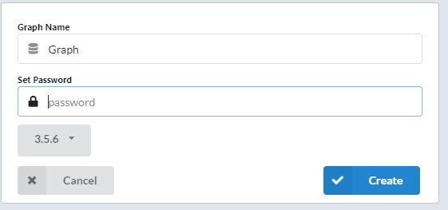
4. Start the graph

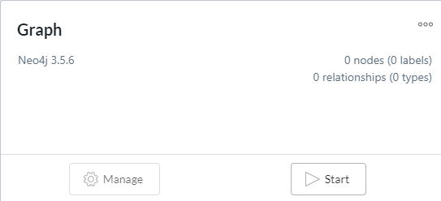

1. From your IDE, enter your username (default as ‘neo4j’) and password set in step 3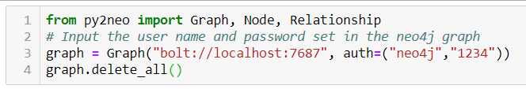
2. Changes in code are sync in Neo4J now

